**Original Context Diagram**

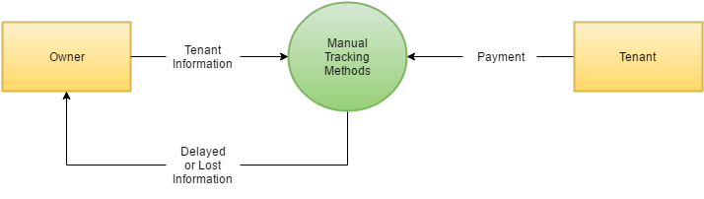

**Proposed Context Diagram**

